Year 3 Spelling and Handwriting Homework
13.6.25
I bought one book. one .

I won the race. won .

Oh no! A bear! bear .

The tree is bare. bare .

A daughter and son! son .

The sun is hot? sun .

A bee makes honey. bee

I like to be kind. be

Be quiet. quiet .

This is quite nice. quite .


Well Done! Now it’s time for ‘5 more to be sure’!!
This is for REVISION of Year 1 and 2 words. Ask them to spell any 5 words from these lists. If they can spell them, that’s great! If they struggle, practise the words on the lines below. Every child is unique and even the most able writers can trip up on spellings! These will not be tested in class.
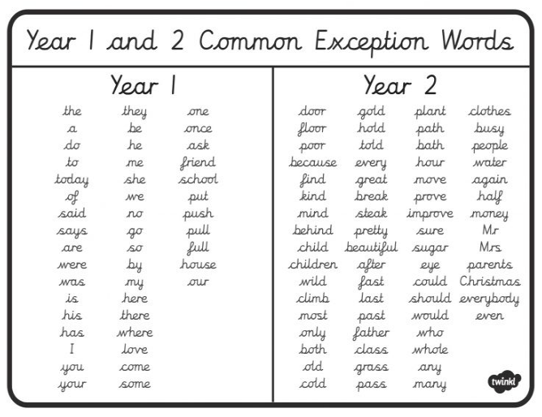

Practise here!

